This is the fourth revision in my project.

In this, the image of memory create on previous step is added in redline tool to analyze it.

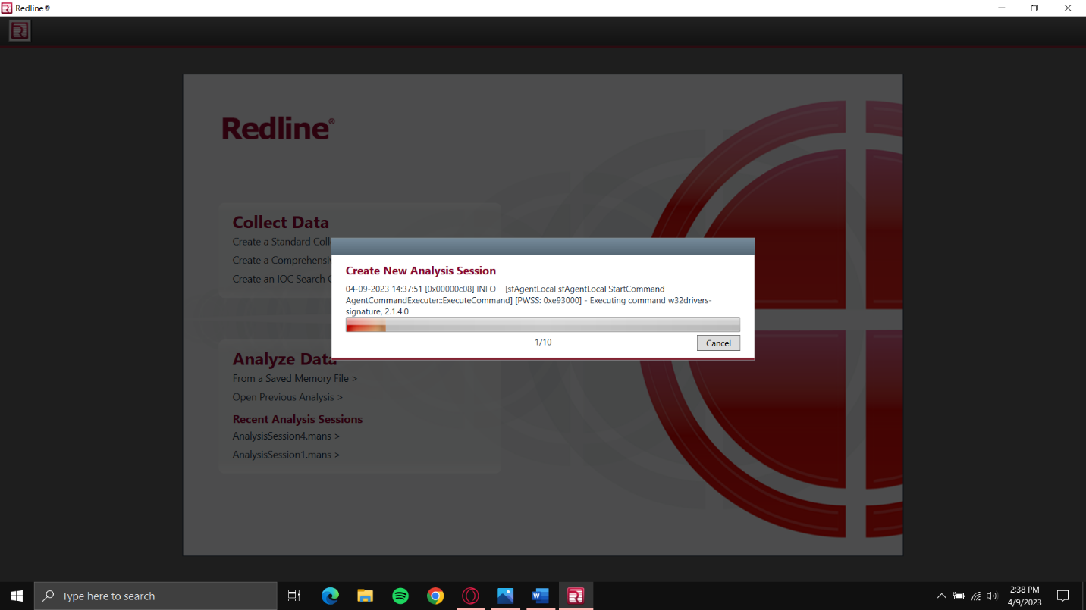

Files are being analyzed and then report is created.

